**The University of New Mexico**

**School of Engineering**

**Electrical and Computer Engineering Department**

**ECE 535 Satellite Communications**

**Student Name: Scott Nguyen**

Module # 7: Problems 7.1, 7.2, 7.6, 7.7, 7.8, 7.12, 7.13

Summer 2025

**Prof. Tarief Elshafiey**

7.1. Describe the TT&C facilities of a satellite communications system. Are these facilities part of the space segment or part of the ground segment of the system?

Telemetry, tracking, and command facilities let the ground station monitor the satellite and send it instructions. Telemetry sends data like temperature, power levels, attitude, and fuel pressure back to Earth so operators can check the satellite’s health. Tracking uses beacon signals from the satellite to follow its position and ranging measures distance by timing signal delays. Commands from the ground control things like satellite orientation, antenna direction, and station adjustments, and these commands are usually encrypted to prevent unauthorized use.

Most of the equipment that supports these functions is located on the ground, so these facilities are part of the ground segment of the satellite communications system.

7.2. Explain why some satellites employ cylindrical solar arrays, whereas others employ solar-sail arrays for the production of primary power. State the typical power output to be expected from each type. Why is it necessary for satellites to carry batteries in addition to solar-cell arrays?

Some satellites use cylindrical solar arrays because they spin, so these arrays can collect sunlight evenly as the satellite rotates. Spinning helps even out temperature and power generation. These cylindrical arrays typically produce a few hundred watts of power. Other satellites use solar-sail arrays, which are flat and fixed, giving more surface area to capture sunlight. These can produce several thousand watts of power, making them suitable for satellites with higher power needs.

Satellites need batteries in addition to solar cells because they pass through Earth’s shadow during each orbit and won’t get sunlight for some time. Batteries store power to keep the satellite running when solar cells aren’t producing energy.

7.6. Briefly describe the three-axis method of satellite stabilization.

The three-axis method of satellite stabilization uses control systems to keep the satellite steady along its three main axes: pitch, yaw, and roll. Instead of spinning, the satellite is held fixed in orientation, pointing its antennas and instruments in the right directions. This is done using devices like reaction wheels or thrusters that make small adjustments to keep it stable and correctly aimed.

7.7. Describe the east-west and north-south station-keeping maneuvers required in satellite station keeping. What are the angular tolerances in station keeping that must be achieved?

East-west station-keeping maneuvers control the satellite’s position along the geostationary orbit, keeping its longitude within set limits. North-south station-keeping maneuvers control the satellite’s latitude, keeping the inclination angle low to maintain a fixed position over the equator.

The typical angular tolerances that must be achieved in station keeping are about 0.1 degrees in both latitude and longitude. These keep the satellite within a small box in space, roughly 147 kilometers on each side, to ensure it stays properly aligned with its coverage area.

7.8. Referring to Fig. 7.10 and the accompanying text in Sec. 7.4, determine the minimum 3-dB beamwidth that will accommodate the tolerances in satellite position without the need for tracking.

From the text and Fig. 7.10, the satellite’s position can vary by about 0.1 degrees in latitude and 0.1 degrees in longitude, making a total tolerance of about 0.2 degrees.

To cover this entire box without needing to track the satellite, the antenna beamwidth must be at least 0.2 degrees. Any narrower beam, like the 0.12-degree beam of a 30-meter antenna, could miss the satellite, so tracking is needed. But a beamwidth larger than or equal to 0.2 degrees will cover the satellite position uncertainty without tracking.

7.12. Draw to scale the uplink and downlink channeling schemes for a 500-MHz-bandwidth C-band satellite, accommodating the full complement of 36-MHz-bandwidth transponders. Assume the use of 4-MHz guardbands.

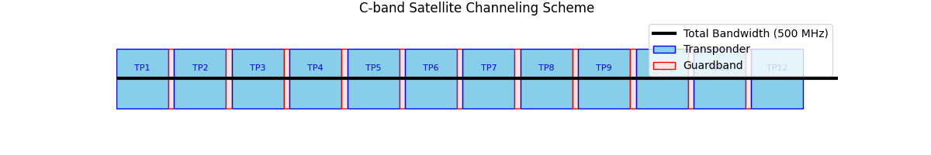

7.13. Explain what is meant by frequency reuse, and describe briefly two methods by which this can be achieved.

Frequency reuse means using the same frequency band more than once within the satellite system to increase capacity. It allows more signals to be sent without needing extra spectrum.

Two common methods are polarization isolation and spot-beam antennas. Polarization isolation uses signals with opposite polarizations, like vertical and horizontal, on the same frequency, and separates them with antennas that match the polarization. Spot-beam antennas divide the coverage area into smaller spots, reusing the same frequencies in different locations without interference. Combining both methods can increase the effective bandwidth a lot.